Public Cloud

☁️ Definition of Public Cloud
# Source: AI Source: Provided by: [Data Path: Persons Table -> ID Column: 1, Name_En Column: Motasem Essam] -> From: [ChatGPT] on [1/26/2026]
A Public Cloud is a cloud computing model where services such as computing power, storage, and applications are delivered over the internet by third-party providers. These resources are shared among multiple organizations (multi-tenant) but are fully managed and maintained by the cloud provider. Users access services on a pay-as-you-go or subscription basis.
Key points:
- Resources are owned and managed by the cloud provider.
- Accessible to anyone over the internet.
- Ideal for organizations that want to avoid the cost and complexity of managing physical infrastructure.

⚙️ Features of Public Cloud
# Source: AI Source: Provided by: [Data Path: Persons Table -> ID Column: 1, Name_En Column: Motasem Essam] -> From: [ChatGPT] on [1/26/2026]
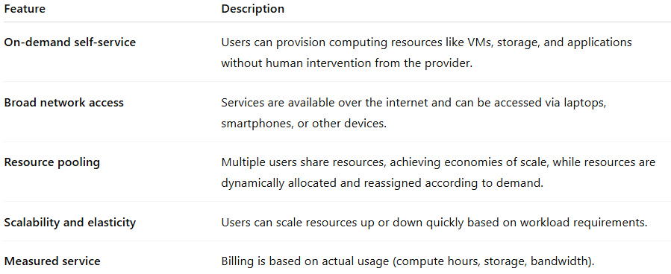
Feature | Description
On-demand self-service | Users can provision computing resources like VMs, storage, and applications without human intervention from the provider.
Broad network access | Services are available over the internet and can be accessed via laptops, smartphones, or other devices.
Resource pooling | Multiple users share resources, achieving economies of scale, while resources are dynamically allocated and reassigned according to demand.
Scalability and elasticity | Users can scale resources up or down quickly based on workload requirements.
Measured service | Billing is based on actual usage (compute hours, storage, bandwidth).

✅ Advantages of Public Cloud
# Source: AI Source: Provided by: [Data Path: Persons Table -> ID Column: 1, Name_En Column: Motasem Essam] -> From: [ChatGPT] on [1/26/2026]
- Cost-effective: No need to invest in on-premises hardware or maintenance.
- Scalable: Easily accommodates spikes in demand without upfront planning.
- High availability: Providers typically offer global data centers and redundancy.
- Reduced IT management burden: Provider handles updates, patching, and infrastructure maintenance.
- Rapid deployment: New services can be provisioned within minutes.

⚠️ Disadvantages / Challenges
# Source: AI Source: Provided by: [Data Path: Persons Table -> ID Column: 1, Name_En Column: Motasem Essam] -> From: [ChatGPT] on [1/26/2026]
- Limited control: Less control over hardware, security, and compliance.
- Security concerns: Data resides in shared infrastructure, which may raise regulatory concerns.
- Dependency on internet connectivity: Services are inaccessible without internet access.
- Potential performance variability: Resource sharing can sometimes lead to inconsistent performance.

🛠️ Public Cloud Service Models
# Source: AI Source: Provided by: [Data Path: Persons Table -> ID Column: 1, Name_En Column: Motasem Essam] -> From: [ChatGPT] on [1/26/2026]
Public cloud providers offer different service models:
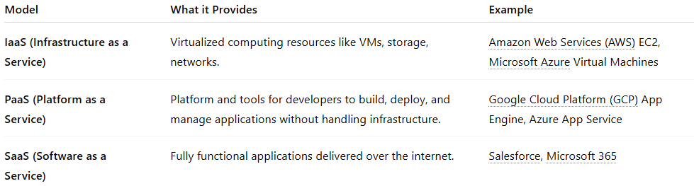
Model | What it Provides | Example
IaaS (Infrastructure as a Service) | Virtualized computing resources like VMs, storage, networks. | Amazon Web Services (AWS) EC2, Microsoft Azure Virtual Machines
PaaS (Platform as a Service) | Platform and tools for developers to build, deploy, and manage applications without handling infrastructure. | Google Cloud Platform (GCP) App Engine, Azure App Service
SaaS (Software as a Service) | Fully functional applications delivered over the internet. | Salesforce, Microsoft 365

🌐 Examples of Public Cloud Providers
# Source: AI Source: Provided by: [Data Path: Persons Table -> ID Column: 1, Name_En Column: Motasem Essam] -> From: [ChatGPT] on [1/26/2026]
- Amazon Web Services (AWS) – Market leader offering IaaS, PaaS, and SaaS solutions.
- Microsoft Azure – Strong integration with Microsoft products, global reach.
- Google Cloud Platform (GCP) – Known for AI and data analytics services.
- IBM Cloud – Focus on hybrid cloud and enterprise workloads.

📝 Use Cases of Public Cloud
# Source: AI Source: Provided by: [Data Path: Persons Table -> ID Column: 1, Name_En Column: Motasem Essam] -> From: [ChatGPT] on [1/26/2026]
- Hosting websites and web applications.
- Backup and disaster recovery solutions.
- Big data analytics and machine learning workloads.
- Software development and testing environments.
- IoT and mobile applications deployment.

📌 Summary
# Source: AI Source: Provided by: [Data Path: Persons Table -> ID Column: 1, Name_En Column: Motasem Essam] -> From: [ChatGPT] on [1/26/2026]
The Public Cloud is a flexible, scalable, and cost-efficient model of cloud computing where resources are owned and managed by third-party providers. It is ideal for organizations looking to minimize IT management overhead, scale rapidly, and pay only for what they use. While it offers high availability and quick deployment, organizations must carefully consider security, compliance, and control limitations. Public cloud services span IaaS, PaaS, and SaaS, with major providers like AWS, Azure, GCP, and IBM Cloud leading the market.

